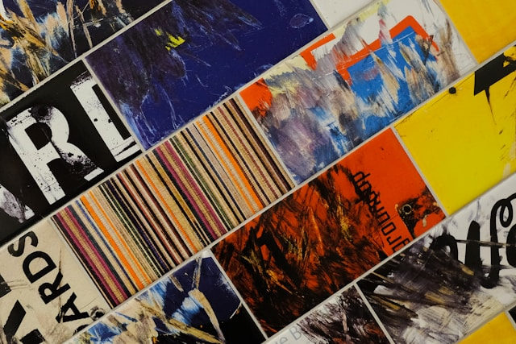
PRWR 226: Desktop Publishing + Newsletters

This course begins from the premise that writing often appears in different contexts, or frames in which the frame or design of the medium impacts the context of writing as much as the selection of individual words. While writing presupposes a certain symbolic brain, visual media remains an earlier and different mode of representation altogether. Images bypass many of the safeguards and ways of reasoning that we have cultivated in literate society, to the point where visual media can represent a blind spot for some writers.

This class seeks to remedy this problem by exposing writers to design concepts—almost solely within Adobe InDesign—so that they may be able to better think how their words are received in magazines, newspapers, newsletters (the one we will spend the most time on), web and other platforms. First and foremost this is not a design class—if asked, you are dealing with page layout this semester—but it is a class meant to sharpen your design eye, and allow you more freedom in creating image and word, text and picture, context and frame.
.
The goal is not that you walk out of here and become a designer, or that you achieve the Adobe certificate for InDesign (although that would be awesome), but that your design eye and awareness of how and why things are designed the way they are become stronger. Hopefully by the end of the term you will be sitting watching a movie and ask why they used that font. You will also be able to see how ease, typography, and color influence the decisions we make almost unconsciously by conveying senses beyond the written word and our rational brains.

Combining these two senses—good design for our words and good sense about what that design does will make your media consumption and production that much better.
Desktop Publishing

Fall 2026

Tues/Thurs 12:00-1:15P
Dr. Robert Foschia
foschia@kutztown.edu
Office: OM 432

Office Hours FA ‘26
T/Th: 4:15-5:30P
Th: 8-9A

Virtual
W/F 11-12P
https://kutztown.zoom.us/j/97419183414

Terry Rydberg (2015). Exploring Adobe InDesign. Cengage Learning

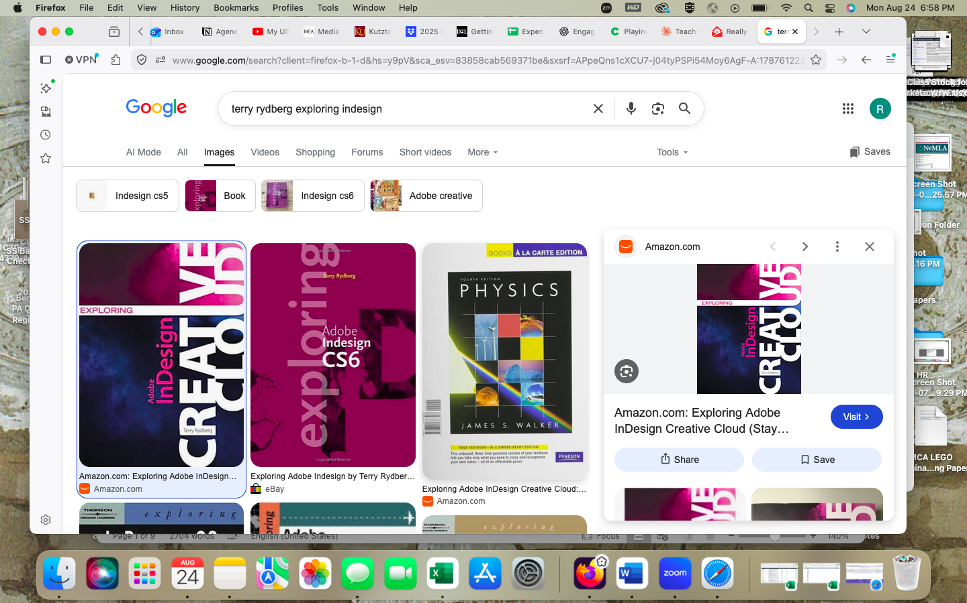

Course Policies
Class Policies

- Attendance Policy: I do not distinguish between “excused” and “unexcused” absences unless your absence is a university-sponsored activity, jury duty, military obligation, or a religious holiday. Life does occur, and if there is an extreme circumstance, I am willing to work with you. However, this does not apply to: traffic, car trouble, large line for coffee (though I will sympathize with this one). You will have two personal days or absences—I don’t need to know what for—that are excused. After that there is a negative effect on your standing in the course.
- Attendance Grading: there is no “reward” for attending (attendance-as-a-grade), however, there is a penalty. After three missed classes I will start to deduct from your overall grade. if you miss eight classes, you will fail the course. Please come speak to me if there is some reason that this number of absences is occurring. It is up to the student to keep track of absences, I will record them, but it your responsibility to know your standing in the class.
- I take attendance at the beginning of class—I will do a preamble of what will be occurring in the class, then I closeout Starfish. If you have not arrived at this time, you are absent—I do not do “lates,” as this will cause me to interrupt class. If you arrive late consistently, I am not going to credit these at the end of the semester. If there is some reason that you arriving late, you need to address this before the end of the semester.
- The penalty for absences is detailed here: 2 missed classes is a 0 point deduction—treat this as your personal time off (PTO) or for emergencies. 3 missed classes equals 1% of your grade. 4 missed classes is a 3.5% deduction; 5 missed classes equals a 7% hit. Penalties from here on become onerous: 6 missed classes is 12%, 7 becomes 19%, and again eight makes the class unpassable.
- If at any time you want to know your attendance record, I can easily pull it up on Starfish and am happy to share it. However, I am not going to hound anyone whether they are in class or not.
- If I show up late, I will add a 1% bonus to everyone’s scores for every session I am late by more than five minutes. I only ask you to do things that I hold myself to account for as well.
- Mid-semester survey: there will be an anonymous mid-semester (early October) survey that will appear on D2L—you do not have to take it, but it is very useful to me if you do and are honest in it. I will be unable to match it to any students, and I do take the feedback seriously. If I can change some things midway, I will try. If the class as a whole gets a 87.5% completion, I will add a bonus to everyone’s grade (but only if you hit this number!).
- If you have a University-sponsored event that causes you to be away from class, please provide documentation before the absence. I will not accept University-sponsored absences to appear at the end of the semester.
- I encourage you to communicate with me throughout the course about the course. Not getting the material? Come see me. Struggling to keep up with assignments? Come see me. Think the book I selected for the course doesn’t work? Once more with feeling. I have office hours throughout the semester and am also willing to work on scheduling.
- Late work: I do not accept late work. This includes dummy links or files I cannot access. If there is an issue in the file format, or a corrupted file, that is part of uploading the assignment. In certain cases I will waive this based on the situation, but not being able to access something is the same as it not being turned in for this class. Once I grade assignments, I move on. My social contract is that in return I will turn around with feedback assignment within two weeks of submission, except in incredibly busy (e.g. finals week, midterm) situations
- If you resubmit an assignment for some reason (with permission from the instructor), you must email me the assignment as well. D2L does not notify me anytime an assignment is resubmitted, and again, I move on.
- I highly encourage students to not reverse engineer rubrics to complete assignments. The rubric is a complement to my own subjective grading of what I know is professional quality. Rubrics and feedback are to demystify the process of how you got the grade, they are not commandments from on high. If you have a question of why I graded something in the way I did, please come visit me (I’ll likely give you a few points back for following up).
- The file formats I will accept are Microsoft Office, Google Suite, PDF, and specific image formats based on the class; note: I will not accept any work in Pages or notes app.
- If you feel the need to have headphones, Airpods, or other devices present, you need to have this clarified with me in the first week. If, after the first week of class I see you have some form of distracting device present I will not ask you to remove I will ask that you remove yourself from the class for the day.
- All writing should be done in a shareable Google Docs file with a revision history. If I suspect A.I usage, I can easily check to see if 3k words just appeared. This keeps mediation of potential plagiarism easy, and if falsely accused you can quickly exonerate yourself. This is a protection for students, not for me.
- I expect you to participate in the course, and to benefit from the interactions with your peers, guest speakers, and professor. If I feel you are distracted by a device, or not engaged in a manner I deem satisfactory, I will provide an alternative assignment to be completed by end-of-week in order to receive credit for that day. Attention is necessary to learn, and I work hard to keep and direct your attention. If you can’t focus attention, you will be unable to learn, practice, and grow as professionals.
- A note on Old Main 130: the classroom is set to be a collaborative environment, in which case I will assign several “in-class” assignments that are not marked on the syllabus. If you are not in class that day, you will not receive credit and there are no makeups (I cannot reproduce the classroom environment, therefore I cannot re-capture the work done). If you have an excused absence, the assignment can be marked exempt if there is a discussion with the professor.

Grading

Below is a breakdown of the grading system used for the class—it will be used for both assignments throughout the semester as well as final grades. If you have a question about your grade, please come and speak with me ASAP. Each assignment will have a rubric attached, but you should complete them based on class discussions, readings, and the assignment rationale (there are few positive outcomes and many bad ones for trying to reverse engineer based on rubrics; the rubrics are there more as a guide for me).

A = 93-100 A- = 90-92 B+ = 87-89 B = 83-86 B- = 80-82 C+ = 77-79 C = 73-76 C- = 70-72 D+ = 67-69 D = 65-66 (65) F = Below 65

Academic honesty policy

**Since this is a technical software class, AI can be helpful for when you get stuck and can’t navigate InDesign. In this way, as a tutor, I believe it can be very valuable. However, using Midjourney or other AI image creators to do the assignments just cheats yourself. I will be putting assignment prompts into different image generators just to see what pops out—so if you turn in 100% verisimilitude copy—I will enact the typical AI policy to the fullest. There isn’t a Google Docs protective layer here, so just please attempt the software and allow yourself to be frustrated. This is as much about sharpening your design eye as it is doing the assignments.**

First—all assignments in this class are to be written in Google Docs—there are features such as revision history that allows me to see your progress as you complete an assignment. I reserve the right to ask for your revision history before assigning a grade. I do this so as to not have to turn to third-party tools like Turnitin, or other somewhat faulty AI detectors.

You will get the most out of this class by producing the work required through your own creative and industrious selves—this includes staying from generative AI (Chat GPT, Claude, Gemini, Perplexity, and other models) as well as “writing tools” like Grammarly. I take academic integrity seriously and have linked to the University’s position on academic integrity.

https://www.kutztown.edu/Departments-Offices/M-R/Registrar/Documents/Forms%20for%20forms%20page/ACA-027%20-%20Academic%20Dishonesty.pdf

The use of generative AI tools is not permitted in this course, with some examples including:

- ‘Brainstorming’ or outlining ideas with generative AI will lead to having the foundation of your work be built on programmatic thinking, and may trigger detectors. This is the most important step in project development, please do not outsource it.
- Writing entire sentences, paragraphs or papers to complete class assignments
- Writing a draft of a writing assignment.

Any assignment that is found to have used generative AI tools in unauthorized ways
will result in a zero on assignments, expulsion from the course, and potential university level consequences.

When in doubt about permitted usage, please ask for clarification.

KU Writing Center

The goal of the KU Writing Center is to aid you in your writing goals and endeavors. I highly suggest using this service for any projects that you might want a fresh set of eyes on. Upon booking a meeting, you and a KUWC consultant will together discover not only means of improving drafts, but also strategies you can use to improve your writing over time. Consultants provide feedback as honest and interested readers, commenting on focus, organization, development, mechanics and style. They are also other voices besides my own that will only help your process (this is not to say to only use them for assignment help, but a combination of the instructor and the service).

Please call 610-683-4733 or email wrcenter@kutztown.edu to set up an in-person appointment. To begin using the WCOnline site and schedule an online session, please go to https://kutztown.mywconline.com. Please see their website for additional helpful instructions and screenshots: https://kutztownwritingcenter.wordpress.com/

Disability Services:

If you have already disclosed a disability to the Disability Services Office (215 Stratton Administration Building) and are seeking accommodations, please feel free to speak with me privately so that I may assist you. If you have an injury sustained during military service including PTSD or TBI, you are also eligible for accommodations under the ADA and may contact the Disability Services Office.

You can reach Disability Services at 610-683-4108 or in Stratton Administration Center 215 for additional information. Their website is:

https://app.kutztown.edu/SZ_001_POLICY_REGISTER/Policy/DIV-004

Kutztown University Non-Discrimination Statement

Kutztown University does not discriminate in employment or educational opportunities on the basis of sex, race, ethnicity, national origin, age, disability, religion, sexual orientation, gender identity or veteran status.

To discuss a complaint of discrimination, please contact the University’s Title IX Coordinator located in the Office of Social Equity, Old Main A-Wing, Room 02, by phone at 610-683-4700 or by email at pena@kutztown.edu or the Office for Civil Rights located in the Lyndon Baines Johnson Department of Education Bldg., 400 Maryland Avenue, SW, Washington, DC 20202-1100, by phone at 800-421-3481 (TDD: 800-877-8339), by fax at 202-453-6012, or by email at OCR@ed.gov.

Disclaimer

The syllabus will most likely undergo some tweaks and modifications as we go through the semester. I will try to ensure that there is always a current version available so that you can check on D2L, and make it note of it in class, online, email, etc.,

Schedule of Classes

Date | Class Topic | Reading Due | Assignment Due
8/25 | Class Welcome | Syllabus and Class Overview | Download Creative Cloud + InDesign  Check out Adobe Education Exchange
8/27 | CRAP and  Design Basics | Digital Institute CRAP Design Principles  Williams, “Joshua Tree Epiphany”  Begin Rydberg Chapter 1 (Menu, Toolbox Save File Formats)
9/1 |  | Rydberg Chapter 1 -Work on Snowman Assignment  Begin Rydberg Chapter Two | Snowman DUE
9/3 | Typeface | Work on Chapter 2 Markup Project
9/8 | Fonts | Rydberg Chapter 3  Williams, ‘Not Helvetica!”  SNL, “Papyrus” | Markup Digital Assets DUE
9/10 |  | Design Challenge #1 Word Art
9/15 | Text and Image Layout | Rydberg, Chapter Four
9/17 | Text and Image Layout | Rydberg Chapter Four | Design Challenge #1 DUE
9/22 | Text and Image Layout | Work on Anna Sanchez project  Gomez-Palacio & Armin Vit, “Of Writing” (on D2L)
9/24 | Tabs | Rydberg Chapter 5 | Anna Sanchez Project DUE
9/29 | Tabs | Rydberg Chapter 5
10/1 | Captions | **Caption Writing Workshop**
10/6 | Tables | Rydberg Chapter 5 | Images and Captions Assignment DUE
10/8 | Color Theory | Rydberg Chapter 12
10/13 | University Schedule Meets as a Monday Schedule |  | Fun in Sun and Calendar Projects DUE
10/15 |  | Design Challenge #2  QUOTE
10/20 | Grids | Rydberg Chapter 6
10/22 | Newsletters + Stacked Objects | Rydberg Chapter 6 | Design Challenge #2 DUE
10/27 | Layers | Rydberg Chapter 7
10/29 | Layers | Rydberg Chapter 7 | Walleye Fishing Guide DUE
11/3 | Effects | Rydberg Chapter 7
11/5 | Paragraph Design | Rydberg Chapter 8  Straub and Buck, Chapter 3 (on D2L) | Hooks and Ladders DUE
11/10 | Snippets | Rydberg Chapter 8
11/12 | CLASS CANCELED –INVITED TALK | Work on Listicle Assignment
11/17 | Listicles and Layout
11/19-22 | CLASS  CANCELED | Professor will be away @ National Communication Association Conference
11/25-11/29 | NO CLASSES- THXGIVING RECESS
12/1 | Work on 2 Page Newsletter |  | Listicle Assignment DUE
12/3 | Work on 2 Page Newsletter  (DUE at Final Exam time)
FINAL NEWLETTER DUE AT FINAL EXAM TIME

